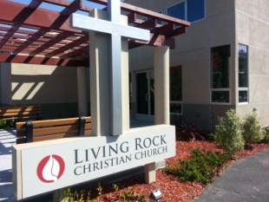
SANTA CLARA COUNTY GOES BACK TO PURPLE TIER EFFECTIVE TUESDAY, NOV. 17
The State’s guidance for Purple Tier for places of worship

Outdoor Only with modifications

Key Prevention Practices

✓ physical distancing to 6ft or more
✓ use of face coverings at all times
✓ frequent handwashing and regular cleaning and disinfection,
✓ temperature check
✓ Stay home when sick

We encourage everyone to follow these guidelines

SCHEDULE OF SERVICES

SUNDAY
10:30 AM WORSHIP SERVICE / FACEBOOK LIVE
ON HOLD SPARK CHILDREN SUNDAY SCHOOL
ON HOLD IGNITE YOUT FELLOWSHIP

WEDNESDAY
7:00 PM PASTOR’S BIBLE STUDY & PRAYER ZOOM MEETING

Living Rock Christian Church
675 E. Taylor Avenue
Sunnyvale, CA 94085

www.livingrockchurch.org
Senior Pastor: Israel Labson
Assoc. Pastor: Edward Sanares

408 245-2026 office@livingrockchurch.org

KFAX AM 1100 Radio Broadcast every Sunday at 11am & Saturday at 5pm

Sermon Podcast at www.livingontherockradio.com
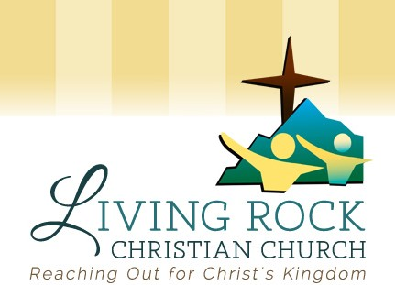

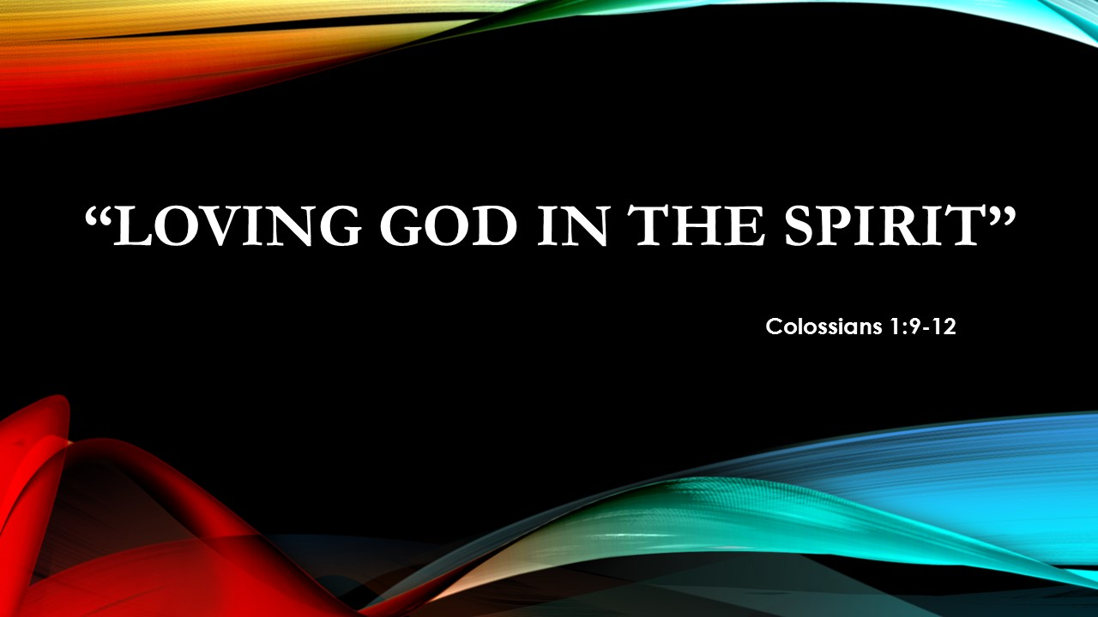

November 22, 2020
By Pastor Israel Labson

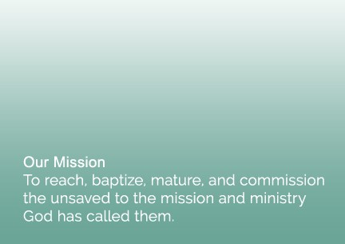
“Loving God in the Spirit”
Thanksgiving 2020
Colossians 1:9-12

For this reason, since the day we heard about you, we have not stopped praying for you. We continually ask God to fill you with the knowledge of his will through all the wisdom and understanding that the Spirit gives,^{[a]} ¹⁰ so that you may live a life worthy of the Lord and please him in every way: bearing fruit in every good work, growing in the knowledge of God, ¹¹ being strengthened with all power according to his glorious might so that you may have great endurance and patience,¹² and giving joyful thanks to the Father, who has qualified you^{[b]} to share in the inheritance of his holy people in the kingdom of light.

1. A Continuous Desire to Know God’s Heart (vs. 9)

For this reason, since the day we heard about you, we have not stopped praying for you. We continually ask God to fill you with the knowledge of his will through all the wisdom and understanding that the Spirit gives

Yes, my soul, find rest in God; my hope comes from him.⁶ Truly he is my rock and my salvation; he is my fortress, I will not be shaken.⁷ My salvation and my honor depend on God^{[a]};he is my mighty rock, my refuge. Psalm 62:5-7

2. A Constant Determination to Make God Happy (vs. 10-11)
¹⁰ so that you may live a life worthy of the Lord and please him in every way: bearing fruit in every good work, growing in the knowledge of God, ¹¹ being strengthened with all power according to his glorious might so that you may have great endurance and patience.

- A Pleasing Life
- A Productive Life
- A Powerful Life

3. A Commitment to Declare our Godly Heritage (vs. 12)

and giving joyful thanks to the Father, who has qualified you^{[b]} to share in the inheritance of his holy people in the kingdom of light.

I pray that the eyes of your heart may be enlightened in order that you may know the hope to which he has called you, the riches of his glorious inheritance in his holy people Ephesians 1:18

Notes:
_________________________________________________________________________________________________________________________________________________________________________________________________________________________________________________________________________________________________________________________________________________________________________________________________________________________________________________________________________________________________________________________________________________________________________________________________________________________________________________________________________________________________________________________________________________________________________________________________________________________________________________________________________

