Sixth Sunday after Easter
May 10, 2026

PRELUDE Lift High The Cross
WELCOME TO WESTMINSTER Elder Dennis Hollinger
PRAYER OF INVOCATION
† CALL TO WORSHIP from Psalm 66
Leader: I will come into your house with burnt offerings; I will pay you
my vows,
People: Those vows that my lips uttered, and my mouth promised
when I was in trouble.
Leader: I will offer to you burnt offerings of fatted calves, with the
smoke of the sacrifice of rams; I will make an offering of bulls
and goats.
People: Come and hear, all you who fear God, and I will tell what he
has done for me.
Leader: I cried aloud to him, and he was extolled with my tongue.
People: Truly God has listened; he has heard the words of my
prayer. Blessed be God.
† HYMN OF PRAISE Stand Up And Bless The Lord (#21)
† SCRIPTURE READING Deuteronomy 31:1-6
† HYMN OF PREPARATION Blessed Be Your Name
PRAYER OF CONFESSION
Holy God, we are inspired by the boldness of your people in the Bible, but we confess that we are often too afraid to be so bold. Our hearts are moved by the love and grace Jesus shared while he walked this earth, but we confess that we rarely follow His example. Forgive our fears. Forgive our inattentiveness. Forgive our pride and selfishness. Transform us with your love and grace anew. In the name of the risen Lord Jesus, we pray...
(Prayers of silent confession)

ASSURANCE OF FORGIVENESS
† DOXOLOGY
JUNIOR CHURCH
OFFERING
† HYMN OF PREPARATION Great Are You, Lord
† SCRIPTURE READING Acts 5:21-32
SERMON Christian Courage
Rev. Owen Stepp
Pastoral Prayer & tHE Lord’s Prayer
Our Father, who art in heaven, hallowed be thy name. Thy kingdom come; thy will be done on earth as it is in heaven. Give us this day our daily bread and forgive us our debts, as we forgive our debtors. Lead us not into temptation but deliver us from the evil one. For thine is the kingdom, and the power, and the glory, forever and ever. AMEN.
† AFFIRMATION OF FAITH Heidelberg Catechism
Q. #1 What is your only comfort in life and in death?

A. That I am not my own, but belong body and soul, in life and in death to my faithful Savior, Jesus Christ. He has fully paid for all my sins with his precious blood, and has set me free from the tyranny of the devil. He also watches over me in such a way that not a hair can fall from my head without the will of my Father in heaven; in fact, all things must work together for my salvation. Because I belong to him, Christ, by his Holy Spirit, assures me of eternal life and makes me wholeheartedly willing and ready from now on to live for him.
† HYMN OF RESPONSE Lift High The Cross (#304)
† BENEDICTION
POSTLUDE Toccata in Seven
Our Prayer Team will be available to pray with anyone in the Chapel following the service.

Welcome to Westminster Presbyterian Church
We are thankful you are here worshiping with us. We invite you to register your attendance with us today on the friendship pad found at the end of the pew.

Upcoming Events
May 17th – 5:00pm Seminar for Youth parents – Join us to hear Kyle Livingston talk about The Role of Anxiety in the Spiritual Formation of Adolescents.
May 17th - 5:30pm Third Third Gathering - The vision is to engage, encourage and equip those entering the “third season” of life. (60+years). Leighton Ford is teaching on The Gift of Aging.
June 14th – 4:00pm – Picnic in the Park – Join us for Fellowship and fried chicken at Freedom Park.

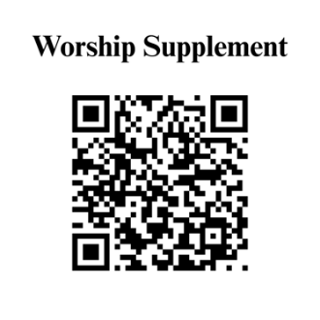

Find out more about Westminster by scanning the codes below with your phone’s camera:


101 Colville Road, Charlotte, NC 28207 | 704-376-0751 | westminstercharlotte.org

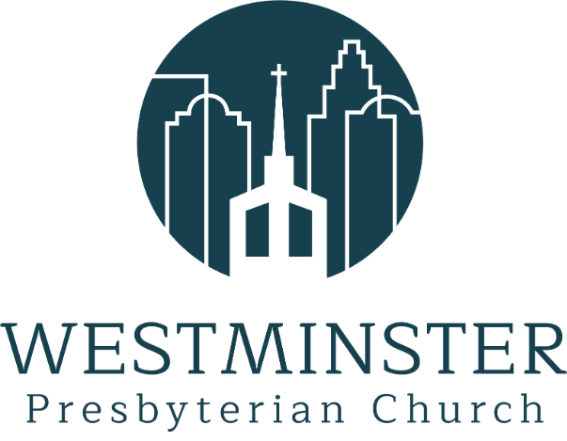

Inviting people to life in Christ…
lived together…
for the sake of others.

