Leadership Sunday
January 11, 2026

PRELUDE
WELCOME TO WESTMINSTER Elder Nate Mitten
PRAYER OF INVOCATION
† CALL TO WORSHIP from Isaiah 60
Leader: Arise, shine, for your light has come,
People: The glory of the LORD has risen upon you.
Leader: For darkness shall cover the earth and thick darkness the
peoples,
People: But the LORD will arise upon you, and his glory will
appear over you.
Leader: Nations shall come to your light and kings to the brightness of
your dawn.
People: Let us worship the Lord who is our light and salvation.
† HYMNS OF PRAISE I Know Whom I Have Believed (#409)
Hymn Of The Holy Spirit
SCRIPTURE READING 2 Timothy 1:6-14
PRAYER OF CONFESSION
Eternal God, in whom we live and move and have our being, whose face is hidden from us by our sins, and whose mercy we forget in the blindness of our hearts: cleanse us from all our offenses, and deliver us from proud thoughts and vain desires, that with reverent and humble hearts we may draw near to you, confessing our faults, confiding in your grace, and finding in you our refuge and strength; through Jesus Christ your Son.
(Prayers of silent confession)
ASSURANCE OF FORGIVENESS
† DOXOLOGY
JUNIOR CHURCH

ORDINATION AND INSTALLATION OF OFFICERS
Elders: Kelly Boyce, Margaret Clayton, Nate Mitten, and Nick Valaoras
Deacons: Courtney Allison, Randy Kate Galvin, Chris Sullivan, Lorene Walker and Susie Wilcox
HYMN OF BLESSING Take My Life and Let It Be (#379)
OFFERING
† SCRIPTURE READING 2 Timothy 2:8-19
SERMON A Leader’s Roots
Rev. Owen Stepp
Pastoral Prayer & tHE Lord’s Prayer
Our Father, who art in heaven, hallowed be thy name. Thy kingdom come; thy will be done on earth as it is in heaven. Give us this day our daily bread and forgive us our debts, as we forgive our debtors. Lead us not into temptation but deliver us from the evil one. For thine is the kingdom, and the power, and the glory, forever and ever. AMEN.
† AFFIRMATION OF FAITH Apostles’ Creed

I believe in God the Father Almighty; Maker of heaven and earth.

And in Jesus Christ His only Son, our Lord; who was conceived by the Holy Ghost, born of the Virgin Mary, suffered under Pontius Pilate, was crucified, dead, and buried; he descended into hell; the third day he rose again from the dead; he ascended into heaven and sitteth on the right hand of God the Father Almighty; from thence he shall come to judge the quick and the dead.

I believe in the Holy Ghost, the holy catholic Church, the communion of saints, the forgiveness of sins, the resurrection of the body, and the life everlasting. AMEN.
† HYMNS OF RESPONSE Yet Not I, but Through Christ in Me
Great Is Thy Faithfulness (#43)
† BENEDICTION
POSTLUDE
Our Prayer Team will be available to pray with anyone in the Chapel following the service.
Welcome to Westminster Presbyterian Church
We are thankful you are here worshiping with us. We invite you to register your attendance with us today on the friendship pad found at the end of the pew.

Upcoming Events
Today –12:15pm - Second Sunday Lunch– Join us for fellowship and food following the 11am service. Come hear the highlights of the Camino trip.
Jan 18th - 5:30pm – Third Third Gathering The vision is to engage, encourage and equip those entering the “third season” of life. (60+years).
Jan 25th - 5:00pm - Youth Group on the Youth Floor.
Jan 27th - 9:45am - Women’s Morning Bible Study - Join us to study the theme of encouragement through Paul's letters.

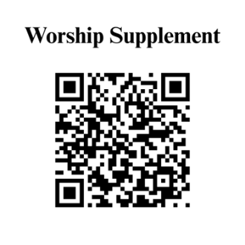

Find out more about Westminster by scanning the codes below with your phone’s camera:


101 Colville Road, Charlotte, NC 28207 | 704-376-0751 | westminstercharlotte.org

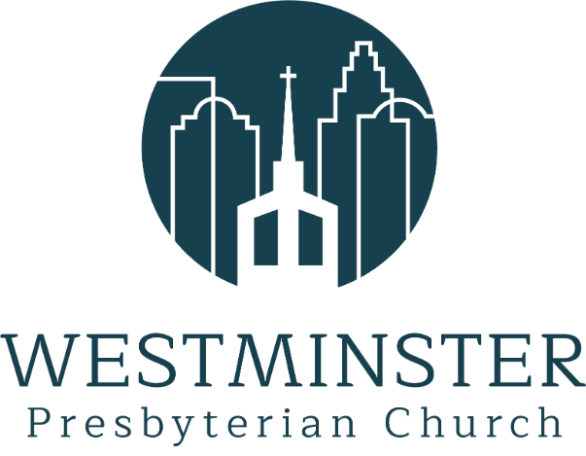

Inviting people to life in Christ…
lived together…
for the sake of others.

