DATE: 5/22/22
TEXT: Mark 8:22-33
TITLE: Lesson from His Journey to Jerusalem Pt. 3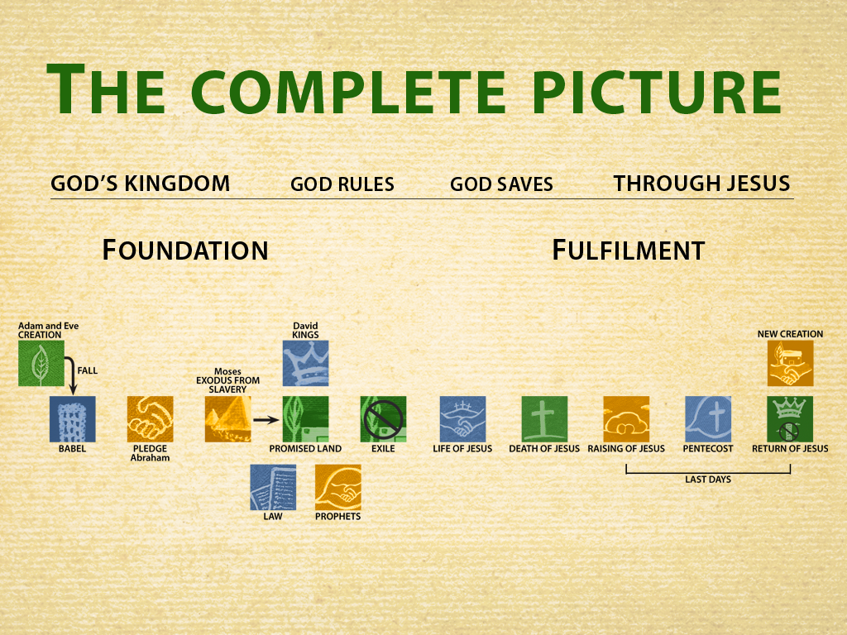

Setting
As we continue in our series in Mark, making progress in chapter eight, we find ourselves with three seemingly distinct stories. Why does Mark put them together? What does he want us to learn?

It is important to keep in mind that Jesus just had the confrontation with the Pharisees and the exchange with his disciples in the boat regarding the leaven of the Pharisees and Herod. Jesus asks some rhetorical questions of his disciples, which serve to highlight their clear lack of understanding. In other words, their spiritual blindness.

Text:
- Mark 8:22-26
  - The uniqueness of this miracle is meant to reflect a spiritual truth for the disciples and us.
- Mark 8:27-30
  - The disciples (in particular Peter) express right understanding of who Jesus is….
- Mark 8:31-33
  - Peter demonstrates a clear lack of understanding of Jesus’ mission and the nature of the kingdom of God.

Explanation
The spiritual truth that this unique miracle reflects is that we too need the continual touch of Jesus. Without it, we will either be completely spiritually blind or, at best, have impaired spiritual vision.

Practice––Drawn from Explanation

Explanation never changes. Practice can and often does have a personal dynamic. Remember this formula: Practice is Explanation applied.

Sharing Questions

- The miracle of the healing of the blind man at Bethsaida is found only in Mark’s gospel. Discuss why you think Mark tells his readers about it and why does he place it here?
- Read Acts 2:1-41. Discuss the clarity of spiritual vision demonstrated by Peter. How did he get it?

