

- Is the Bible Pro-Slavery? -

Ice-Breaker:

The Slave Bible removed 80% of the Bible to make it ‘safe’ for slave-owners. If you were to compile your own version of the Bible, what topics or stories would you leave out and why?

Discussion:

1. Read Revelation 7:9; Galatians 3:28; Acts 17:26.

- What is God’s perspective of the status of humans relative to one another when it comes to race/ethnicity or social status?
- What does this imply about our relationships with others?

2. Read 1 Corinthians 12:13; Acts 11:26; Acts 13:1.

- How is Jesus’ church to be characterized in terms of race and ethnicity?
- How did the early church leadership exemplify this?

3. Consider the following examples of Biblical commands that consistently undermined the power
of slave owners. What does this teach us?

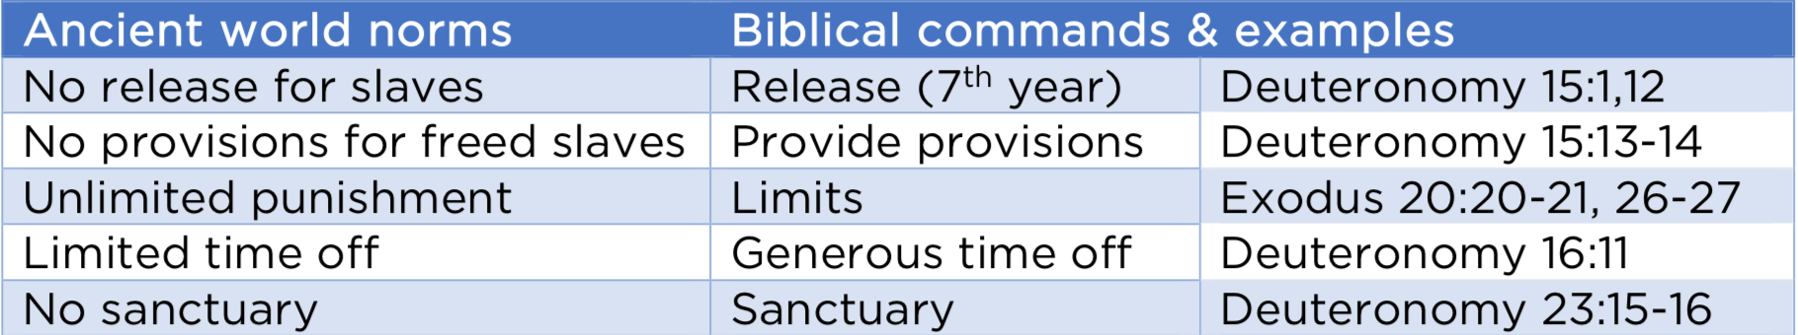

4. Read I Peter 2:18; Ephesians 6:5; Colossians 3:22. When you consider these verses (together
with the verses you’ve already discussed), what is the bigger picture that brings these three verses into harmony with the rest of the teaching of the Bible on slavery?

Application:

- How much do you embrace the value of others in your life?
- Where do you need God’s help to accept and love those who differ from you?
- What will change in your relationships this week, with God’s help?

