Title: Be Faithful to Gather
Text: Acts 2:42-47
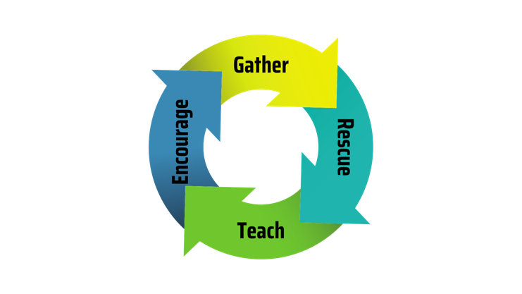

Main Idea: When the ________________ Gather, God Does Something __________________!

1. Faithful People are a __________________ People (vs. 42-43)
- The Apostles’ __________________ -
- The __________________ - (Gk. koinōnia, “participation, sharing”)
- The Breaking of __________________ -
- The __________________ -

2. Faithful People are a __________________ People (vs. 44-45)

3. Faithful People are a __________________ People (vs. 46-47)

What will I do with what I have heard?

Connection Group Reflection Questions
1. What do these verses teach me about our character?
2. What do these verses teach me about God and his character?
3. Because these words are from God, they are TRUTH! What truth is he asking me to believe?
4. What do I need to do to obey him?
5. With whom can I share these truths?

