Leadership Sunday
January 18, 2026

PRELUDE
WELCOME TO WESTMINSTER Elder Margaret Clayton
PRAYER OF INVOCATION
† CALL TO WORSHIP from Psalm 47
Leader: Clap your hands, all you nations; shout to God with cries of joy.
People: For the Lord most high is awesome, the great King over all the
earth.
Leader: He chose our inheritance for us, the pride of Jacob, whom he
loved.
People: God has ascended amid shouts of joy, the Lord amid the
sounding of trumpets.
Leader: Sing praises to God, sing praises; sing praises to our King, sing
praises.
People: For God is the King of all the earth; sing to him a psalm of praise.
† HYMNS OF PRAISE Holy, Holy, Holy! (#262)
How Great Is Our God
SCRIPTURE READING 2 Timothy 3:10-17
PRAYER OF CONFESSION
O Holy Spirit, you guide us and lead us to Jesus. You show us we are children of God. However, we often do not follow your leadership. We refuse to live as children of God. We live selfishly. We live out of fear. We refuse to be generous. Our gifts from you are squandered for the sake of our own comfort. Spirit of Life, lead us into the deep waters. Lead us away from our self-centeredness and show us more of Jesus so that we may be like Him. In His merciful name we pray...
(Prayers of silent confession)
ASSURANCE OF FORGIVENESS
† DOXOLOGY
JUNIOR CHURCH
OFFERING
† SCRIPTURE READING 2 Timothy 4:1-8
SERMON One Final Word
Rev. Owen Stepp
Pastoral Prayer & tHE Lord’s Prayer
Our Father, who art in heaven, hallowed be thy name. Thy kingdom come; thy will be done on earth as it is in heaven. Give us this day our daily bread and forgive us our debts, as we forgive our debtors. Lead us not into temptation but deliver us from the evil one. For thine is the kingdom, and the power, and the glory, forever and ever. AMEN.
† AFFIRMATION OF FAITH Heidelburg Catechism
Q. #1 What is your only comfort in life and in death?

A. That I am not my own, but belong body and soul, in life and in death to my faithful Savior, Jesus Christ. He has fully paid for all my sins with his precious blood, and has set me free from the tyranny of the devil. He also watches over me in such a way that not a hair can fall from my head without the will of my Father in heaven; in fact, all things must work together for my salvation. Because I belong to him, Christ, by his Holy Spirit, assures me of eternal life and makes me wholeheartedly willing and ready from now on to live for him.
† HYMNS OF RESPONSE Speak, O Lord
O God Our Help In Ages Past (#52)
† BENEDICTION
POSTLUDE

Our Prayer Team will be available to pray with anyone in the Chapel following the service.

Welcome to Westminster Presbyterian Church
We are thankful you are here worshiping with us. We invite you to register your attendance with us today on the friendship pad found at the end of the pew.

Upcoming Events

Tonight - 5:30pm – Third Third Gathering The vision is to engage, encourage and equip those entering the “third season” of life. (60+years).
Jan 25th - 5:00pm - Youth Group on the Youth Floor.
Jan 27th - 9:45am - Women’s Morning Bible Study - Join us to study the theme of encouragement through Paul's letters.

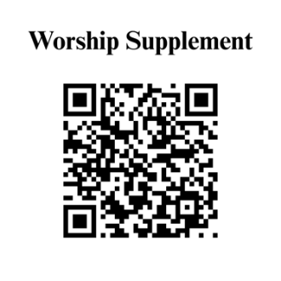

Find out more about Westminster by scanning the codes below with your phone’s camera:


101 Colville Road, Charlotte, NC 28207 | 704-376-0751 | westminstercharlotte.org

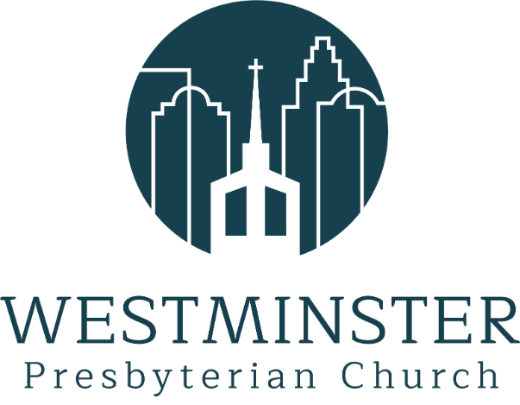

Inviting people to life in Christ…
lived together…
for the sake of others.

